Computer Logic lab

- Using the partial circuit, which can be found on the common folder, complete the ripple carry adder, which is capable of adding 2 4-bit numbers. Test your circuit by adding the following 4 bit numbers:

  - 0011 + 0111 = a
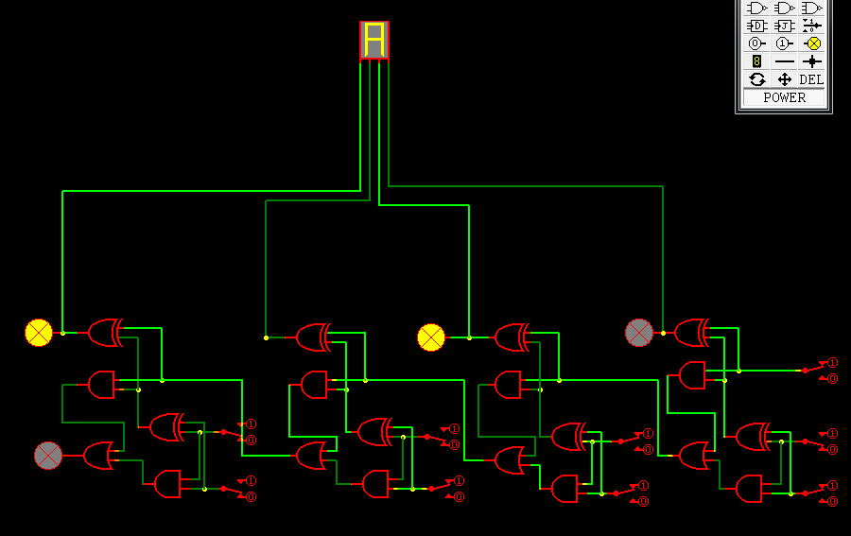

  - 0101 + 0001 = 6

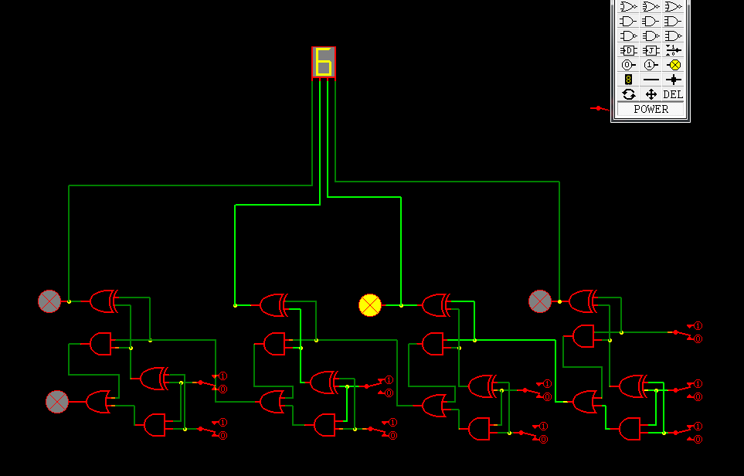

  - 0011 + 0010 = 5

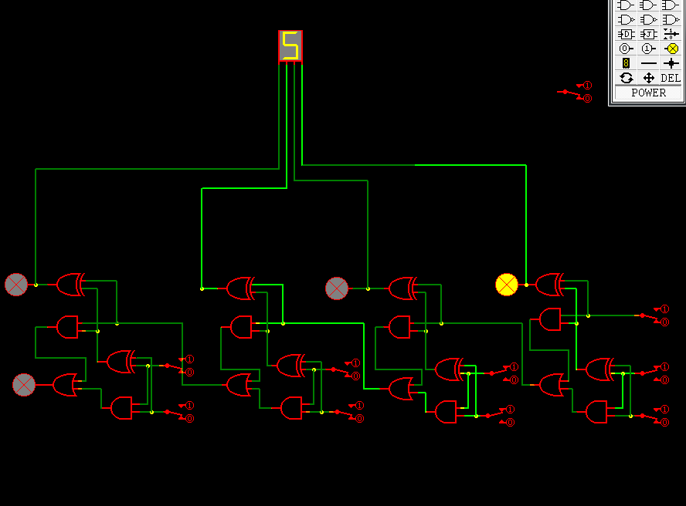

  - 1000 + 0011 = b
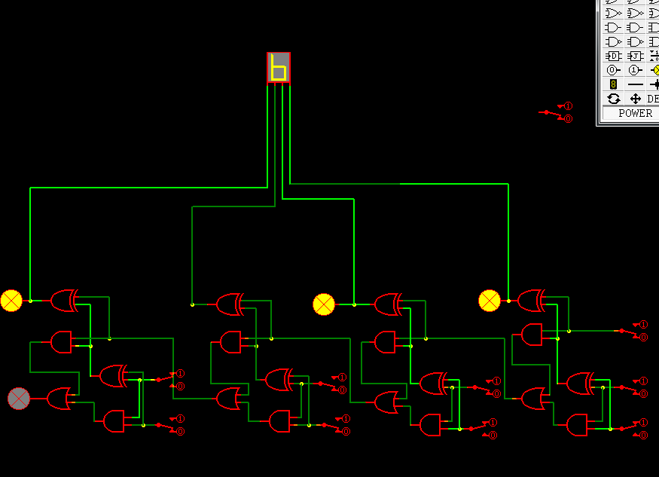

  - 1010 + 0011 = d

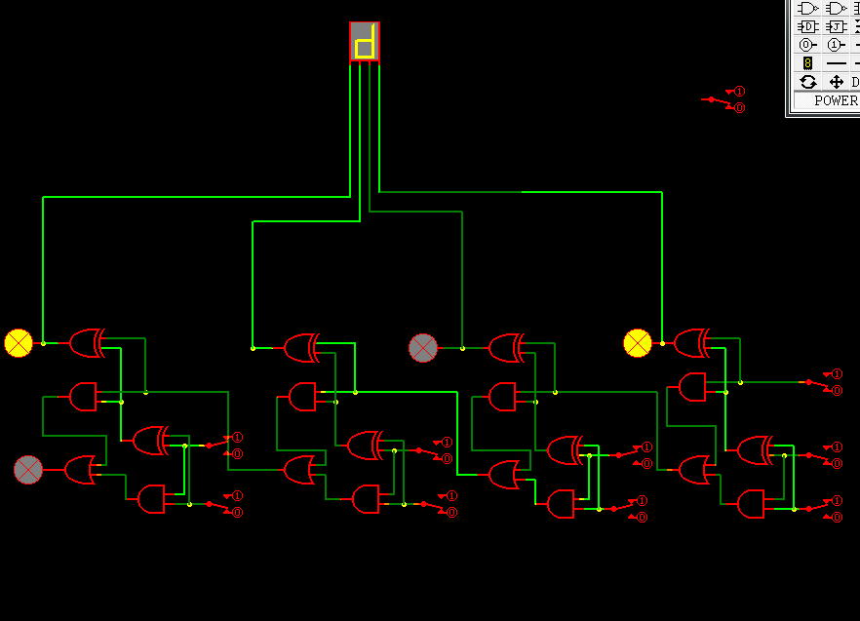
  - 1101 + 1000 = 5
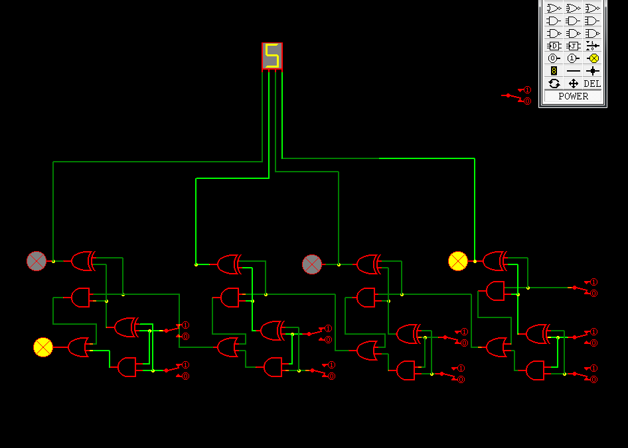

- Using a black box design, draw the 4-bit ripple carry adder below:

- Complete the following truth table for a binary half subtractor

A | B | Sum | Borrow
0 | 0 | 0 | 0
0 | 1 | 1 | 1
1 | 0 | 1 | 0
1 | 1 | 0 | 0

- Using the sum of products technique, design a binary half subtractor. Draw the circuit below and test the circuit using Easysim.

Circuit:

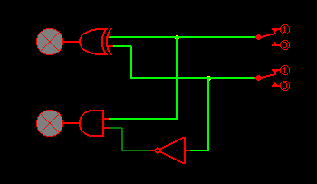

- Using the Sum of Products techique, design a circuit which implements the following truth table. The inputs are A, B, and C. The output is X

Truth Table:

A | B | C | X
0 | 0 | 0 | 1
0 | 0 | 1 | 0
0 | 1 | 0 | 1
0 | 1 | 1 | 0
1 | 0 | 0 | 1
1 | 0 | 1 | 0
1 | 1 | 0 | 1
1 | 1 | 1 | 0

Circuit:

- Simplify the Boolean expression in part 5 using the Rules of Boolean Algebra. Redraw the simplified circuit in EasySim.

